
University Park Public Library
Henna Tattoo Permission Slip

Children ages 10–19 years old may participate in this program with a signed permission slip at the time of registration.
I give permission for my child, ________________________________________, to participate in the Henna Tattoo Program at the University Park Public Library on Wednesday, November 18, from 1:00 PM to 3:00 PM. I understand that during this program, henna will be applied to hands or arms create a temporary tattoo. The design may stay on for up to three weeks. Participants will receive one design of their own choosing. Only those who have a signed permission slip will be allowed to have a henna tattoo.
I understand that neither the University Park Public Library nor any of their employees will be held responsible for any harm or allergic reaction that could result from participation in this event. If your child has any allergies or skin sensitivities, please take special consideration before signing this form.
Signature of Parent/Guardian: ____________________________________________
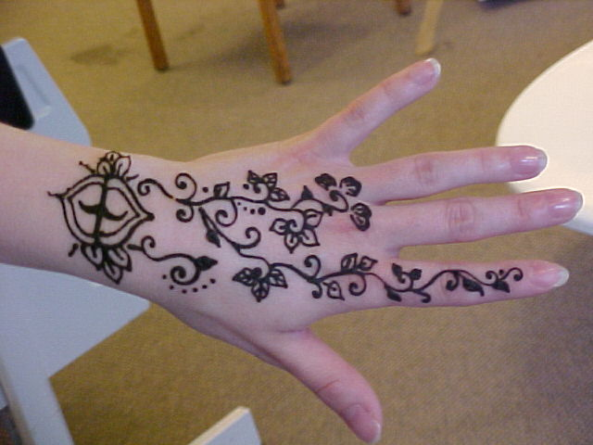
Phone: ____________________________
Date: ____________________________

Henna body art is made by applying henna paste to the skin, where it creates a temporary red-brown stain. Henna is made from a flowering plant grown in tropical and subtropical regions. This art form has been practiced for centuries in India, Africa, and the Middle East.

